**Project scope**

e-AskMe is designed to provide compatibility with the most recent features and to work with PHP, SQL, JavaScript, HTML, CSS, and other languages as needed, as well as to incorporate the most recent OS system to run the project successfully.

The project's proposal and features have been finalized, and work will now focus on analyzing and functional needs. The purpose of e-AskMe is to be the easiest and most convenient place to generate content, connect with people, and distribute ideas from the web to those who need it, and it will be done in 4 months, as planned. The tasks are evenly distributed, and each team member is doing their share to achieve the best results possible.

Costs

Costs are not included because we are still in the early stages of the project, but they will be shared evenly among the team members.

Deadlines

All team members are working closely to complete the tasks and are putting forth their best efforts to complete them on time. Tasks are addressed on a frequent basis in case of complications.

# **Use Cases**

Following are some of the use cases of the system.

## Student Use Case

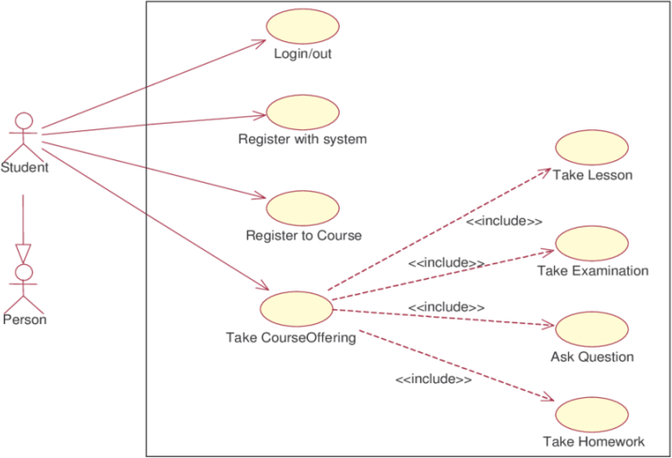

Specialist Use Case

Figure 2 Student Use Case

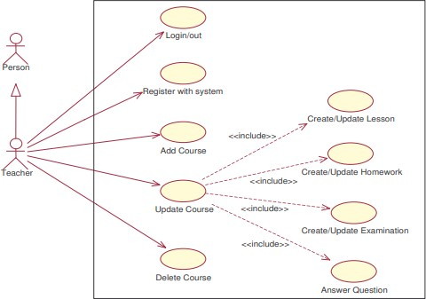

Figure 3 Teacher Use Case

## System Administrator Use Case

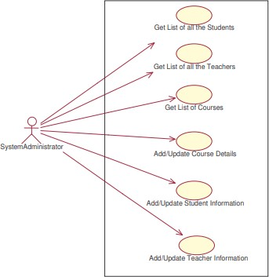

Figure 4 System Administrator Use Cases

**User Story**

As e-AskMe, we wish to build a website that combines eLearning and question answering in an efficient manner to assist learners in the learning process.

Acceptance Criteria:

1.Students should use their login and password to enter the website and review their previous achievements.

2.Students should enroll in a course to receive materials and instruction.

3.A voting mechanism is employed to prioritize the content.

4.Questions and queries from learners should be answered by the specialists.

5. A search field is available on the top-bar.

6. The search language is English.

**Functional Requirements**

Users express their requirements to the project team primarily through functional requirements. Functional requirements assist in keeping the project team on track.

**Login**

Users must be able to log into their accounts using their email and password, as well as their Google and Facebook accounts. Users must be able to reset their passwords by clicking forgot password and receiving an email with a link sent to their verified email address.

**Mobile friendliness**

In today's world, an ever-increasing number of Internet users conduct searches on their phones or tablets rather than on their laptops or computers. As a result, mobile-first design continues to thrive as a more advanced adaptive design alternative.

**Live chat**

Live Chat is one of the most popular services on websites because it allows customers to get immediate responses to their inquiries. It would be ideal to include an online chat feature on the website where customers could get immediate responses to their issues. Simulate a simple algorithm for a chatbot, which would lower the number of calls to live operators, at the same time.

**Business rules**

Business rules outline the relationships between items, such as client names and their related orders, to govern day-to-day decision-making in enterprises. A website can save time and money by simplifying work to the relevant stakeholders and minimizing turnover by enforcing business rules across an organization. Business rules lay the groundwork for automation systems by converting undocumented or documented data into a variety of conditional assertions.

**Search Engines**

Search engines serve as filters for the vast amount of information available on the internet. Users may quickly and easily access material that is of true interest or worth, without having to sift through a plethora of irrelevant web pages, thanks to search engines.

**Non-functional requirements**

A non-functional requirement is a specification that outlines the system's operation capabilities as well as the limitations that help it perform better.

**Performance**

System performance is the most significant quality in non-functional criteria, and it has an impact on practically all of the others. The system performance of e-AskMe is designed to be rapid, allowing it to reply to a specific user's activity in a given workload.

**Reliability**

E-AskMe is designed to be dependable since work has been done to ensure that the system will run without fail for a particular number of usage or period of time.

**Maintainability**

The majority of the time, all of the members are trying to resolve maintainability concerns and quickly recover the system following a failure.

**Security**

On e-AskMe, security is a top priority, and we're all working hard to ensure our users' safety and privacy. These features are required since we do not want anyone to have access to the sensitive data of our users.

**Usability**

The mechanism of e-Askme is easier to find and use.It has been designed so that anyone can use it successfully and efficiently.